

Spring Chickens Website

Design Documentation



May 5, 2020

Kai Tindall

Contents

Purpose of the proposed website 3

Specification 3

Data Structures 3

Users table 3

Trips table 4

Subscriptions table 4

ResetTokens table 4

Posts table 5

HomeTexts table 5

CarouselItems table 5

CalendarEvents table 6

Designs 6

Design Ideas 6

Trip Display 6

Admin Home 7

Contact Page 7

All Feeds 8

Home Page 8

New Admin Account 9

New Post 9

Final Design 11

Home Page (Admin Logged in) 11

Home Page (Standard user logged in) 12

Home Page (No user logged in) 12

Sign up 13

Events page 13

All trips (no user logged in) 14

All trips (standard user logged in) 14

All trips (admin user logged in) 15

Individual trips (no or standard user) 15

Individual trips (admin user) 16

Admin abilities page 16

Forgot password 17

New Trip 17

New Post 18

Manage calendar 18

Create event 19

Manage carousel 19

New carousel Item 20

Manage homepage text 20

User promotions 21

# Purpose of the proposed website

The purpose of the website is to enable the customer to manage their media presence more effectively than they had been able to before. This would mean the website would have to be able to store and present images of their trips and be able to notify users when there is a new photo that has been uploaded.

The site is acting as a replacement for their word of mouth updates and partial media storage, which is currently just both of their mobile phone’s internal storage.

The site should also be able to be a source of knowledge on their upcoming trips and important notifications.

This website will serve as a tool to allow the customer to be able to take a picture, upload it, and then be done with it. They will not have to manually send their family and friends images or tell them updates; the site will notify them itself.

# Specification

|  |  |
| --- | --- |
| ***Requirement Id*** | ***Requirement*** |
| *SPRING_001* | The site shall have a landing page that can show important updates. |
| *SPRING_002* | The site shall have the ability to create a user account |
| *SPRING_003* | The site shall have the ability to promote users to administrator status. |
| *SPRING_004* | The site shall have the ability to upload a post. |
| *SPRING_005* | A post shall have the option to have a photograph within the post. |
| *SPRING_006* | The site shall be able to divide posts into Trips. |
| *SPRING_007* | A user shall be able to reset their password. |
| *SPRING_008* | The site shall have a calendar which shows upcoming events. |
| *SPRING_009* | The site shall use ASP.NET Core 3 |
| *SPRING_010* | The site shall use bootstrap |
| *SPRING_011* | The site shall have contact information listed |

# Data Structures

This section details each data structure that will be found in the database that the site will use.

As the chosen database connectivity solution is Entity Framework Core, which is a C# library that handles database transactions, I will be listing the data types in their C# types rather than the actual database types as by using entity framework it decouples the implementation of the SQL language used. In this instance I am using an MSSQL database, but it could be changed to a MySQL database or any other database provider by changing one line of code. Therefore, I think the SQL type is irrelevant for this design document.

## Users table

|  |  |  |
| --- | --- | --- |
| ***Name*** | ***Type*** | ***Purpose*** |
| Id | Int | To serve as a unique identifier field. |
| UserName | String | To give the user a friendly name to log in with |
| Hash | String | Their salted, hashed password. This will be checked against credentials when they attempt to log in |
| Salt | String | A salt that will enable a higher level of security for user’s passwords. |
| Email | String | To be able to email reset password or notification emails to the user. |
| AdminRights | Bool | To check whether the user is allowed administrator privileges. |

## Trips table

|  |  |  |
| --- | --- | --- |
| ***Name*** | ***Type*** | ***Purpose*** |
| Id | Int | To serve as a unique identifier field. |
| TripName | String | To give the trip a human friendly name |
| TripDescription | String | To give users a bit more insight into what the trip is about more than just the name. |
| DateTimeLastActivity | DateTime | To allow trips to be sorted depending on what is the most relevant. |

## Subscriptions table

|  |  |  |
| --- | --- | --- |
| ***Name*** | ***Type*** | ***Purpose*** |
| Id | Int | To serve as a unique identifier field. |
| TripId | Int | To mark which trip the user wishes to be subscribed to |
| UserId | Int | To mark which user wishes to be subscribed |

## ResetTokens table

|  |  |  |
| --- | --- | --- |
| ***Name*** | ***Type*** | ***Purpose*** |
| Id | Int | To serve as a unique identifier field. |
| UserId | Int | To mark which user the reset token belongs to |
| TokenString | String | The unique token identifier that will be emailed to the user. |
| ExpiryTime | DateTime | The time at which the token ceases to be valid |
| IsDead | Bool | To indicate if this token has died for whatever reason. |

## Posts table

|  |  |  |
| --- | --- | --- |
| ***Name*** | ***Type*** | ***Purpose*** |
| Id | Int | To serve as a unique identifier field. |
| TripId | Int | To identify what trip this post belongs to |
| PhotoFileName | String | The name of the photo associated with this post. |
| Title | String | A brief description of the post |
| BodyText | String | The main body of the post |
| DateTimePosted | DateTime | Stores the date and time this was posted for use in updating the rankings of the trips. |

## HomeTexts table

|  |  |  |
| --- | --- | --- |
| ***Name*** | ***Type*** | ***Purpose*** |
| Id | Int | To serve as a unique identifier field. |
| Title | String | To act as the main headline |
| Body | String | To give more detailed information |

## CarouselItems table

|  |  |  |
| --- | --- | --- |
| ***Name*** | ***Type*** | ***Purpose*** |
| Id | Int | To serve as a unique identifier field. |
| PhotoFilePath | String | To be able to get the photo associated with this item |
| Title | String | To act as the headline for this item |
| Description | String | A more detailed understanding of the title |
| IsActive | Bool | Whether or not this will be displayed in the home page carousel |
| Position | Int | The ranking this item has compared to all the other items. This determines the order it is shown on the carousel |

## CalendarEvents table

|  |  |  |
| --- | --- | --- |
| ***Name*** | ***Type*** | ***Purpose*** |
| Id | Int | To serve as a unique identifier field. |
| Date | DateTime | Stores the date of the event |
| Description | String | Stores the description of the event. |

# Designs

## Design Ideas

I first created some basic wireframe designs for the main pages of my website. These would later be refined into a more detailed mock-up after I had solidified some design decisions in my head.

I also took HCI into consideration, using colour to highlight important parts of the page, and maintaining the three click rule to act as a guide in my navigational ideas.

### Trip Display

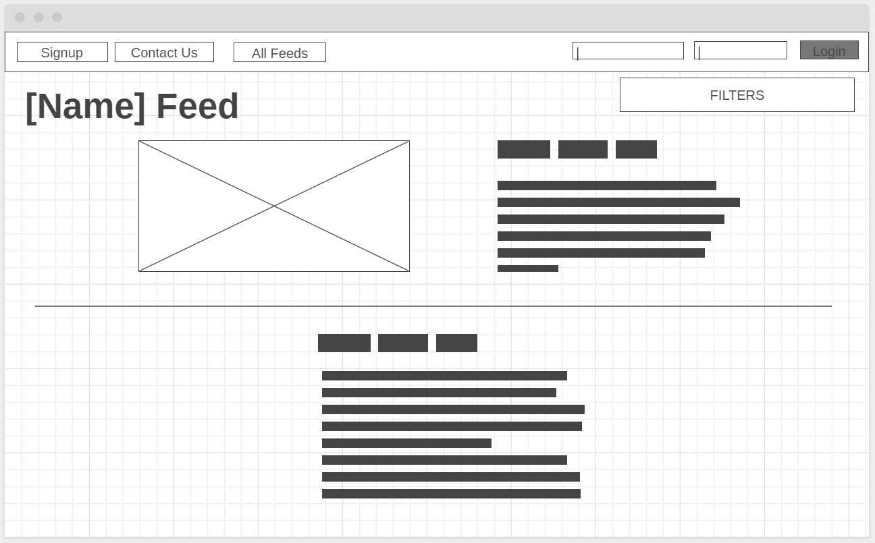

### Admin Home

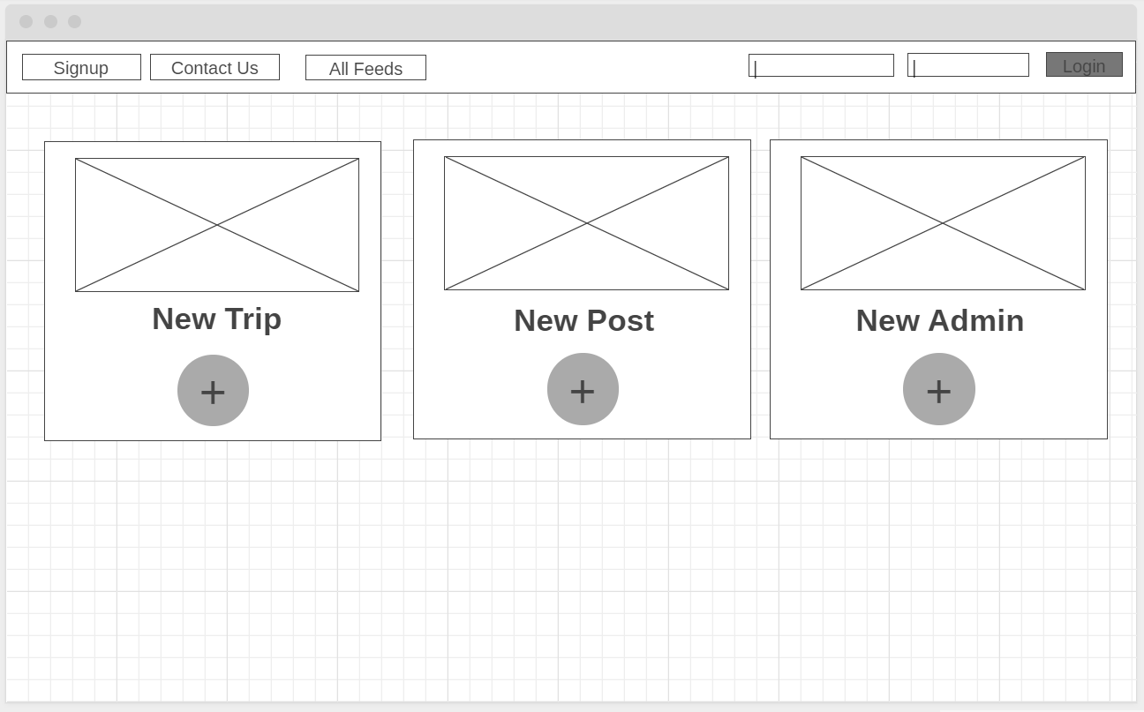

### Contact Page

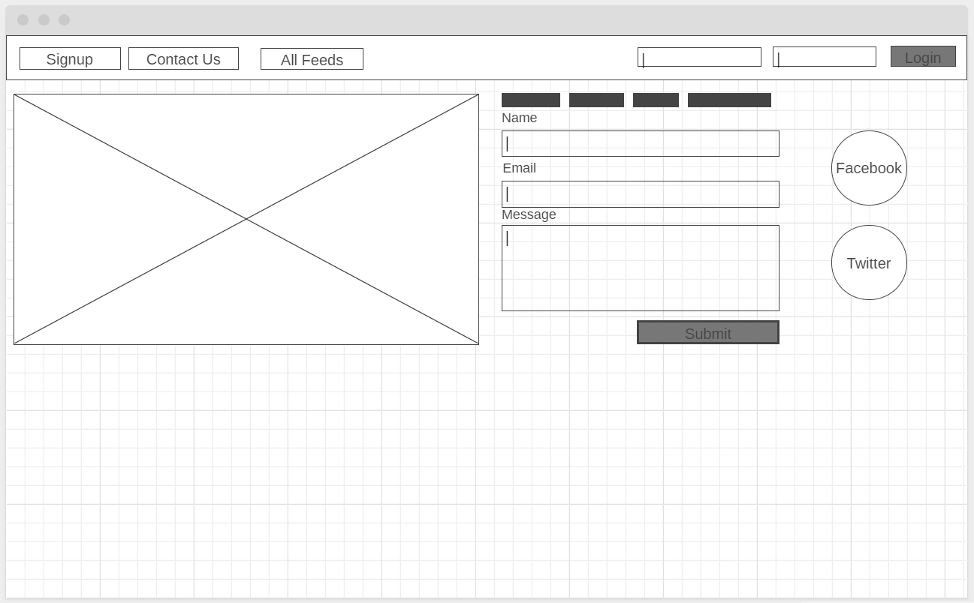

### All Feeds

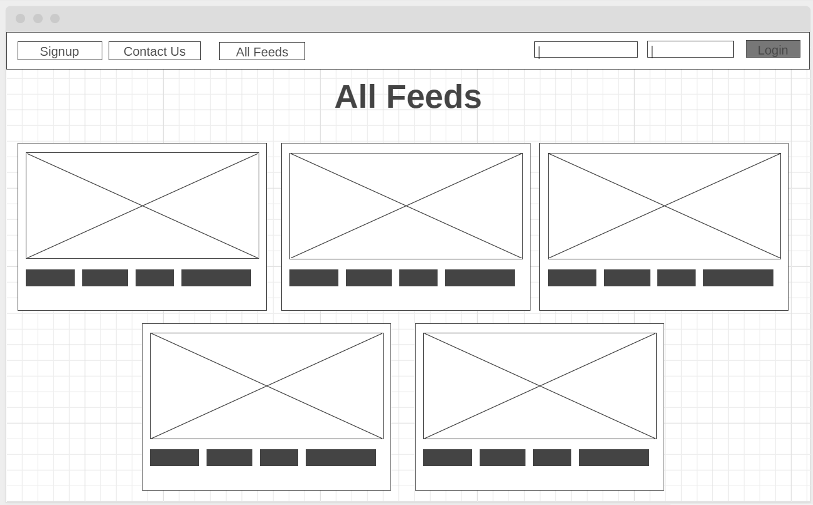

### Home Page

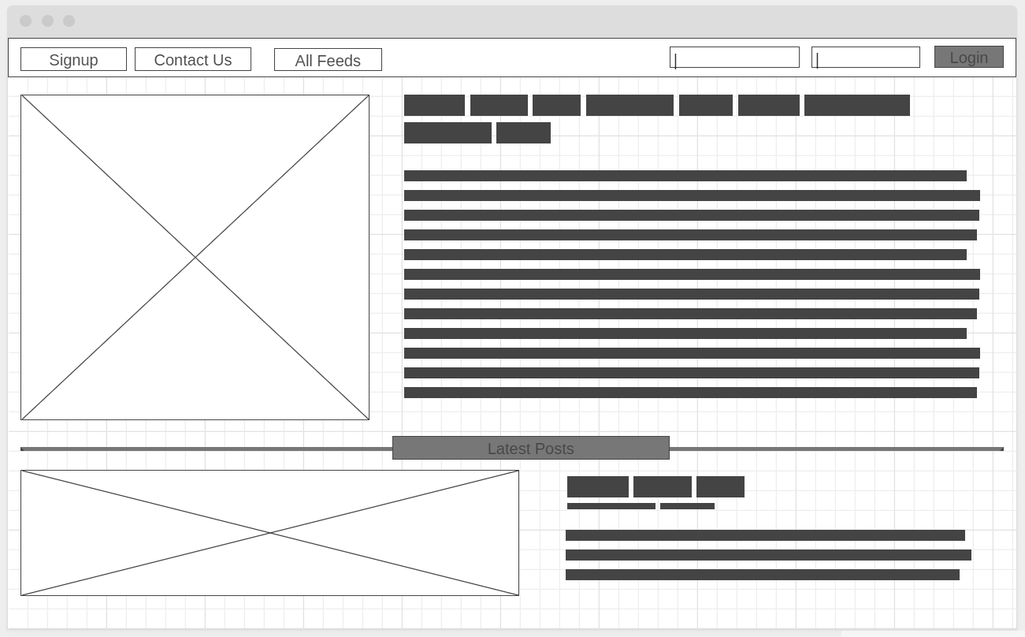

### New Admin Account

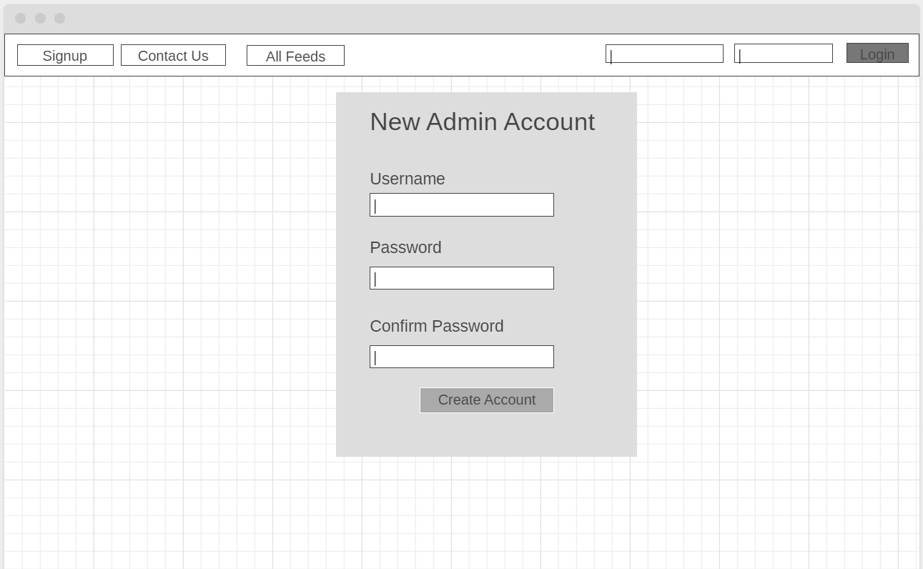

### New Post

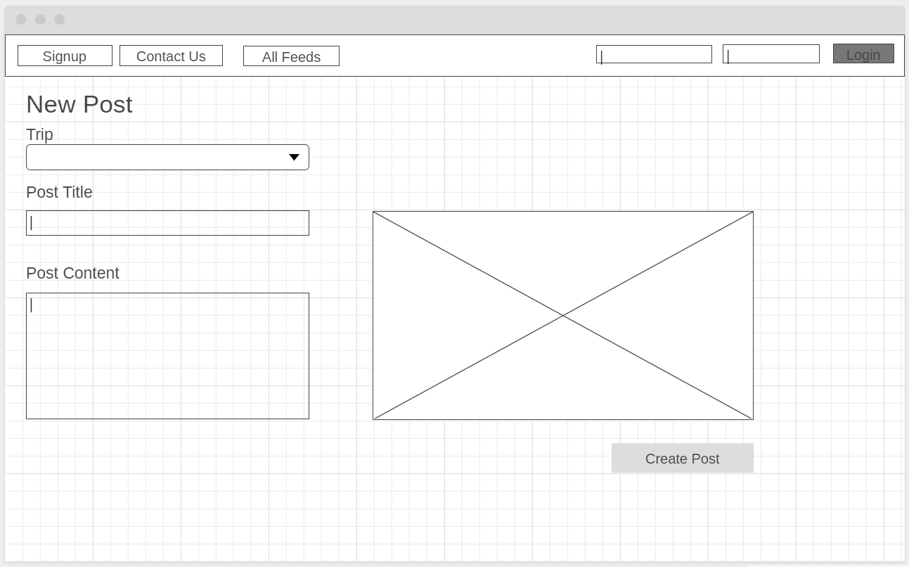

New Trip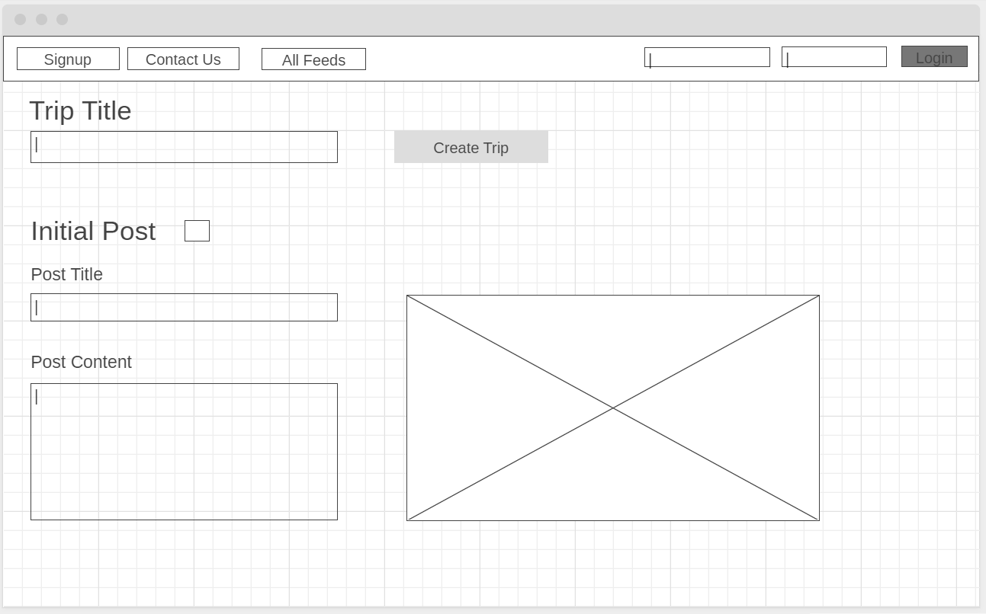

New User Account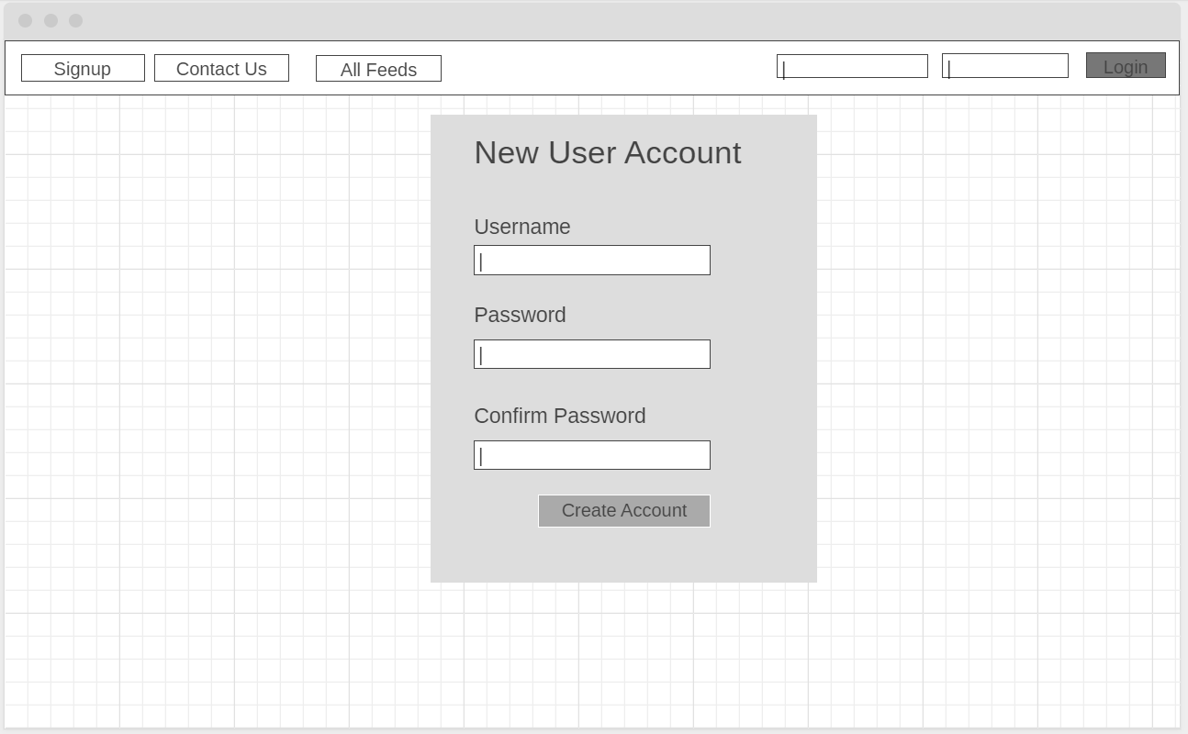

Preferences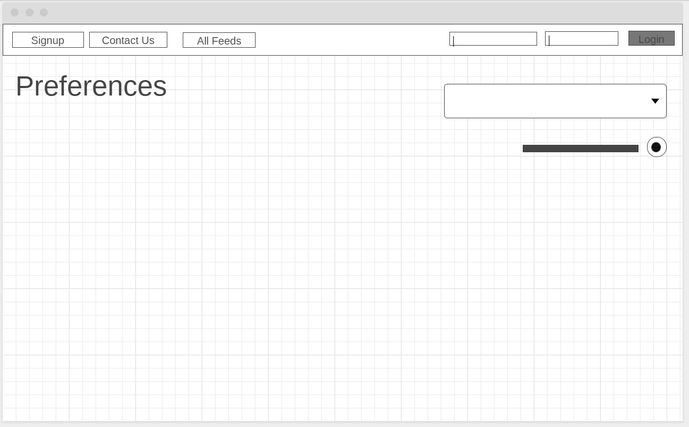

## Final Design

### Home Page (Admin Logged in)

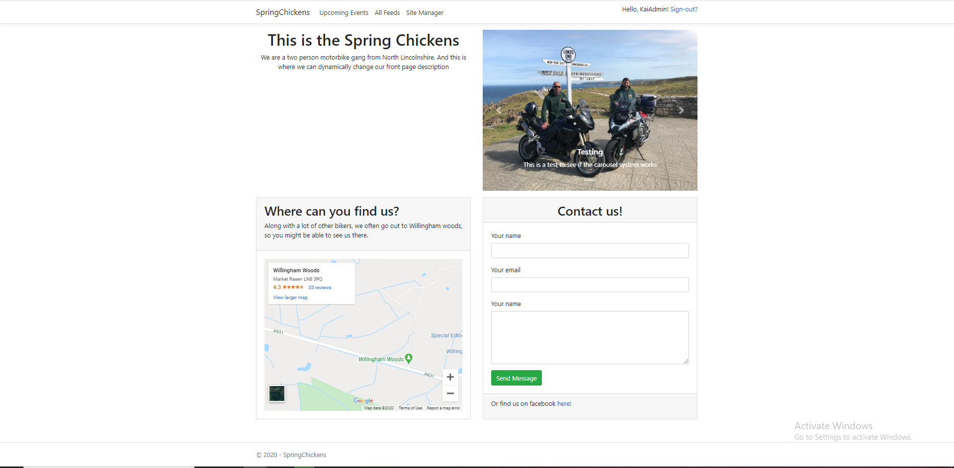

### Home Page (Standard user logged in)

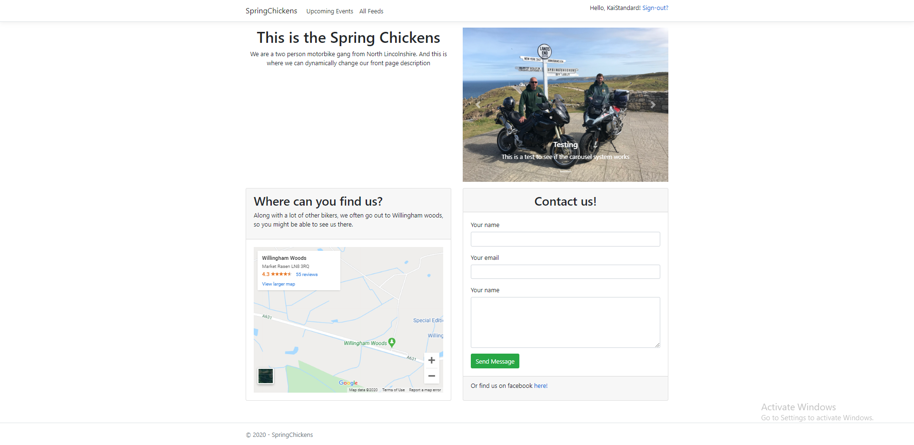

### Home Page (No user logged in)

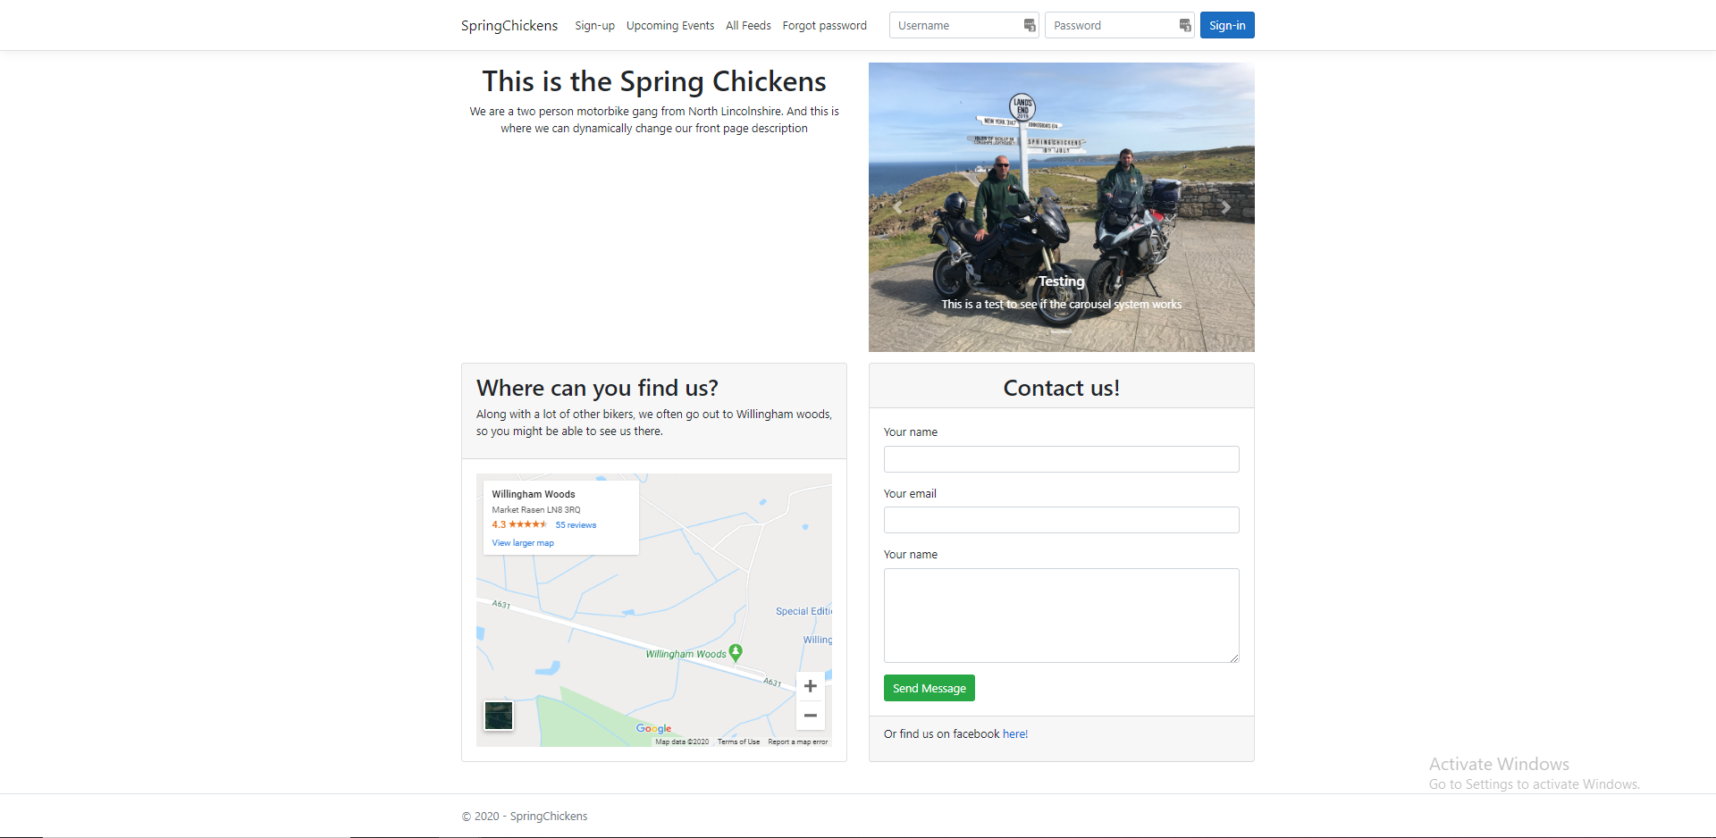

### Sign up

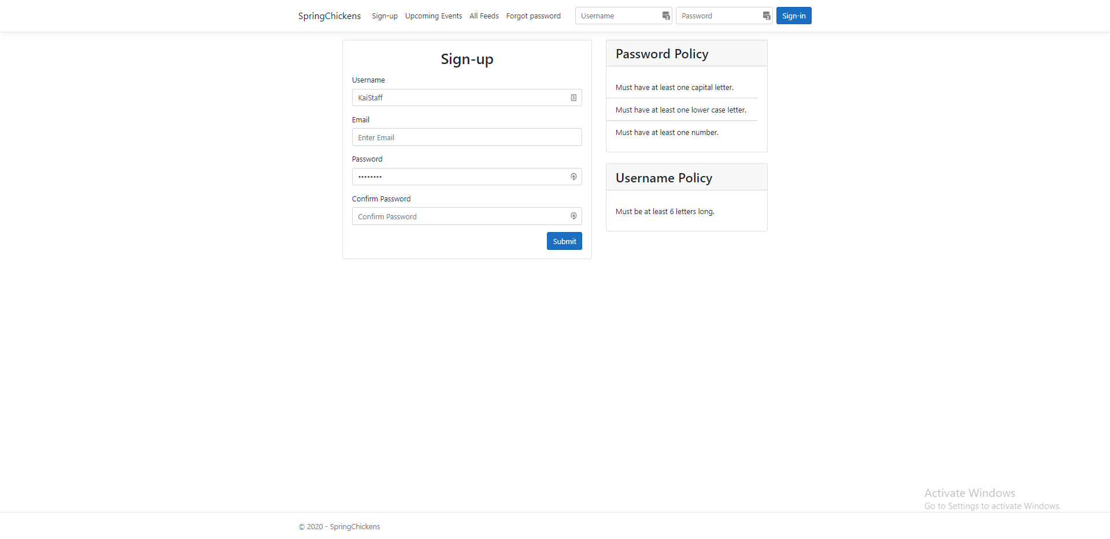

### Events page

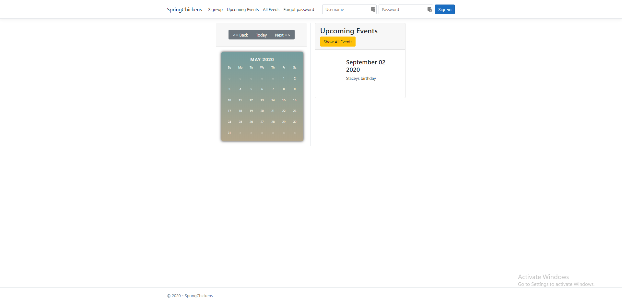

### All trips (no user logged in)

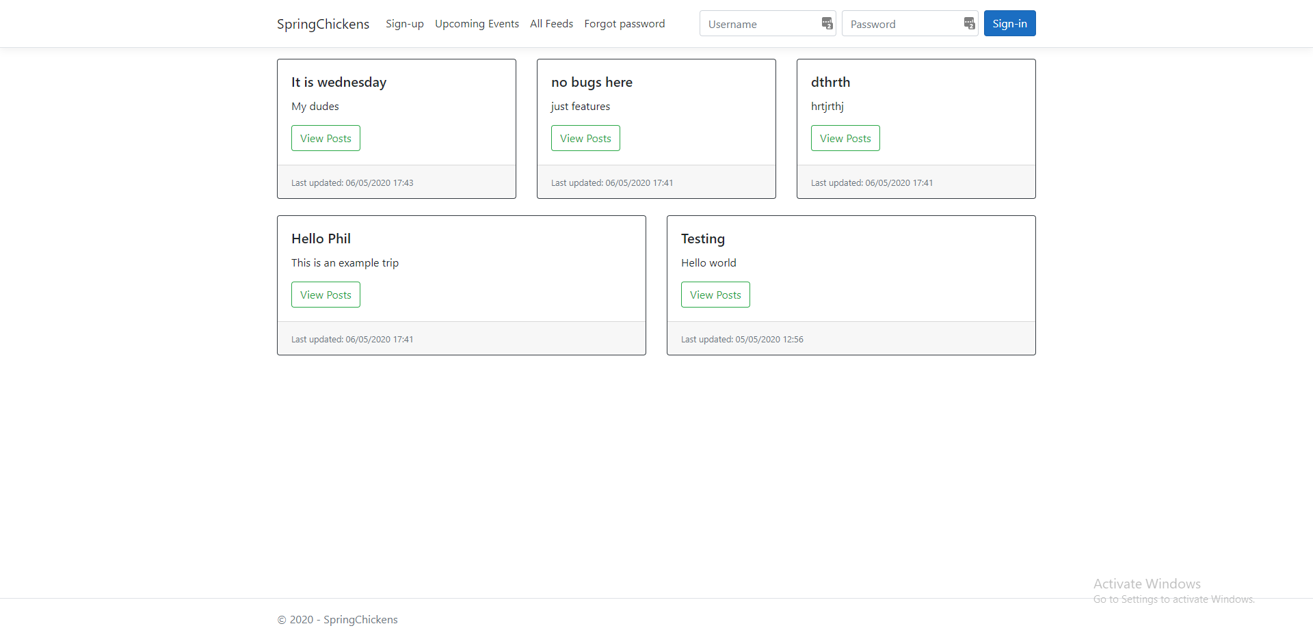

### All trips (standard user logged in)

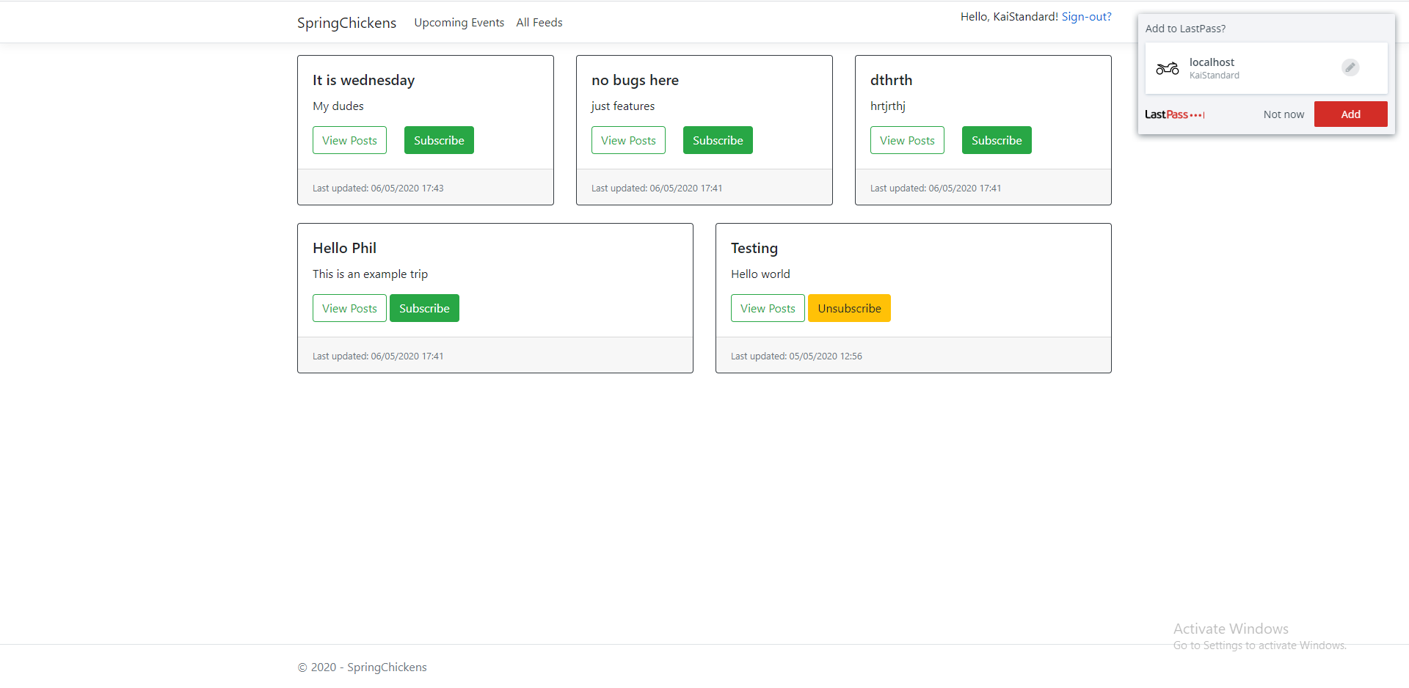

### All trips (admin user logged in)

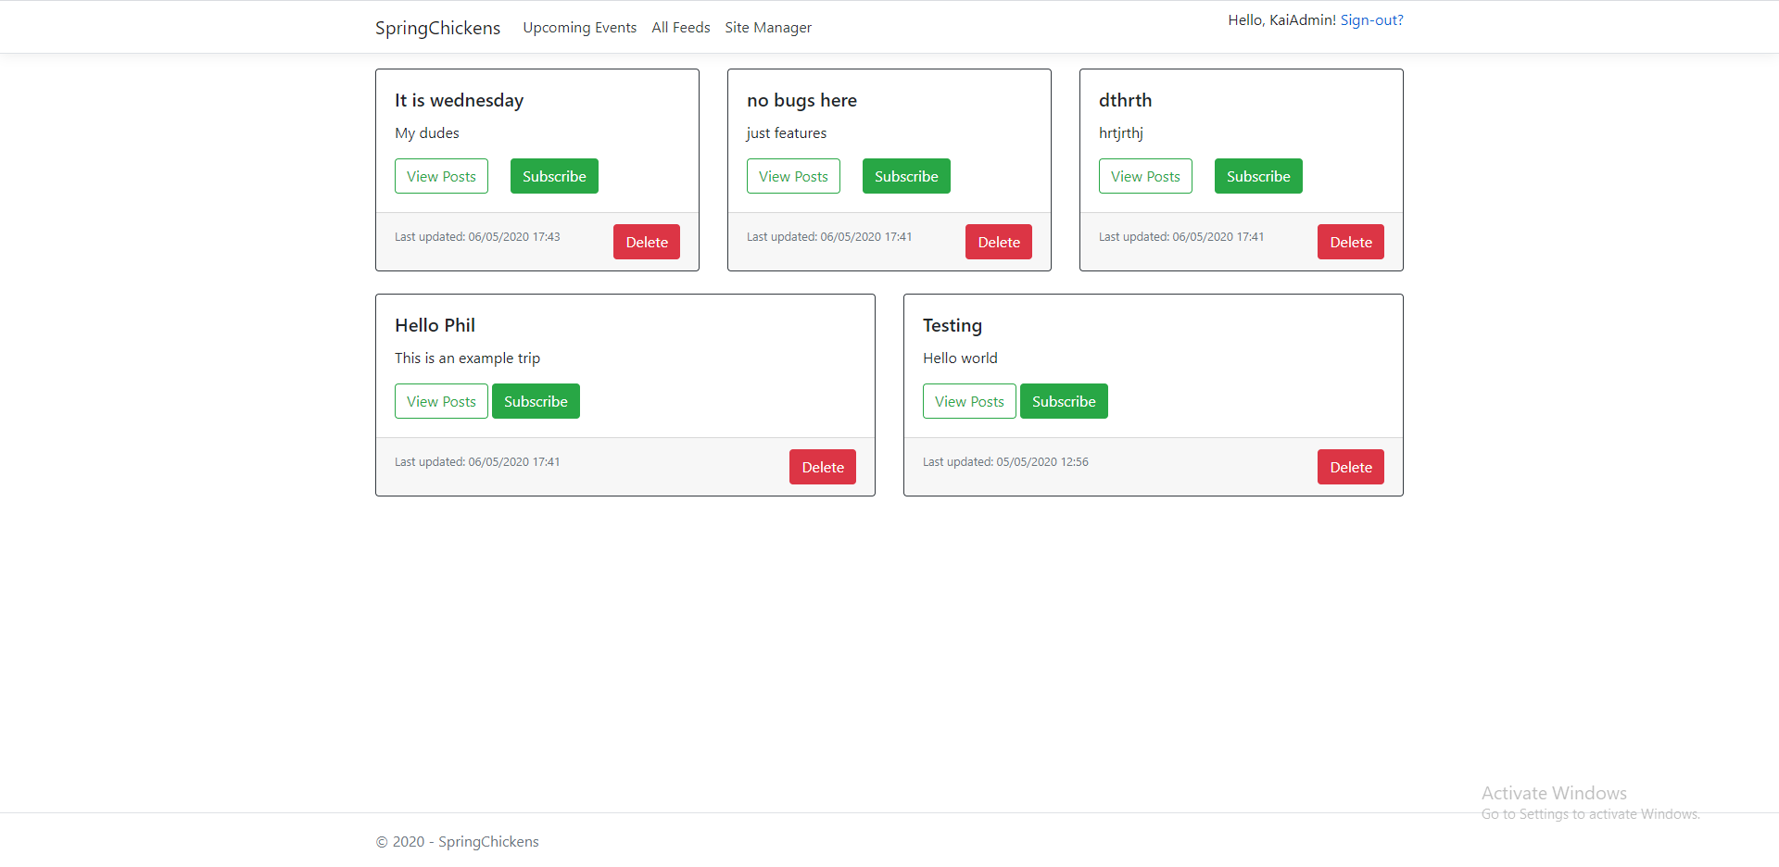

### Individual trips (no or standard user)

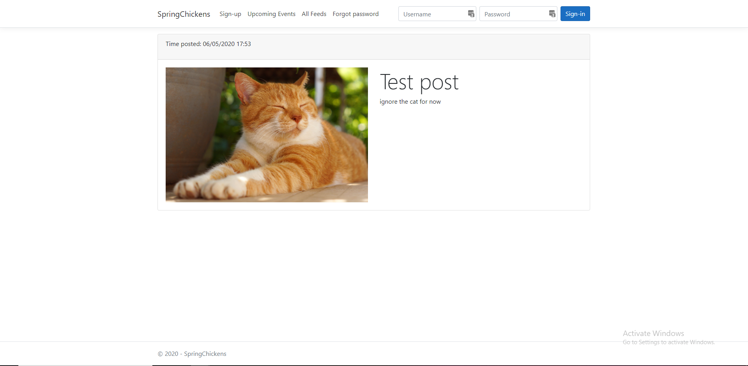

### Individual trips (admin user)

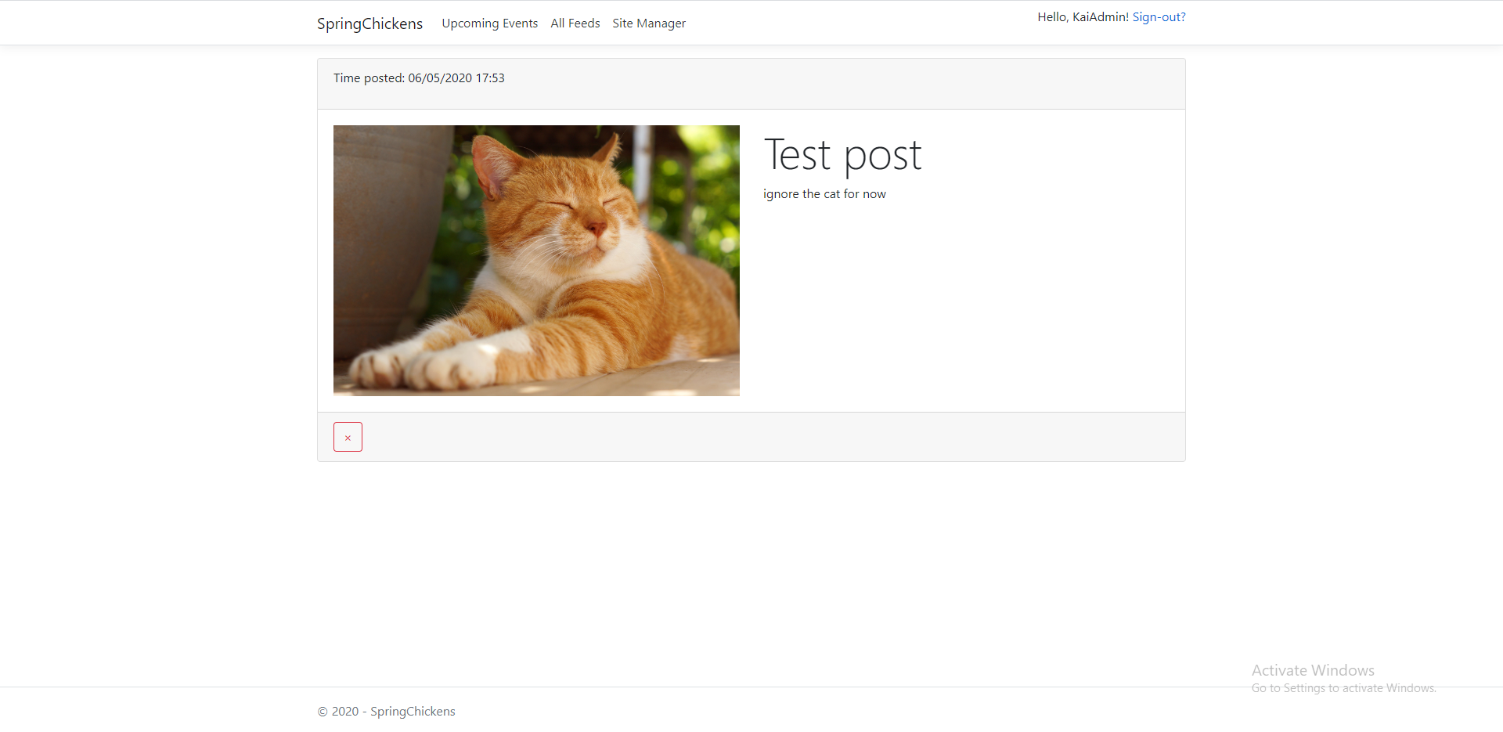

### Admin abilities page

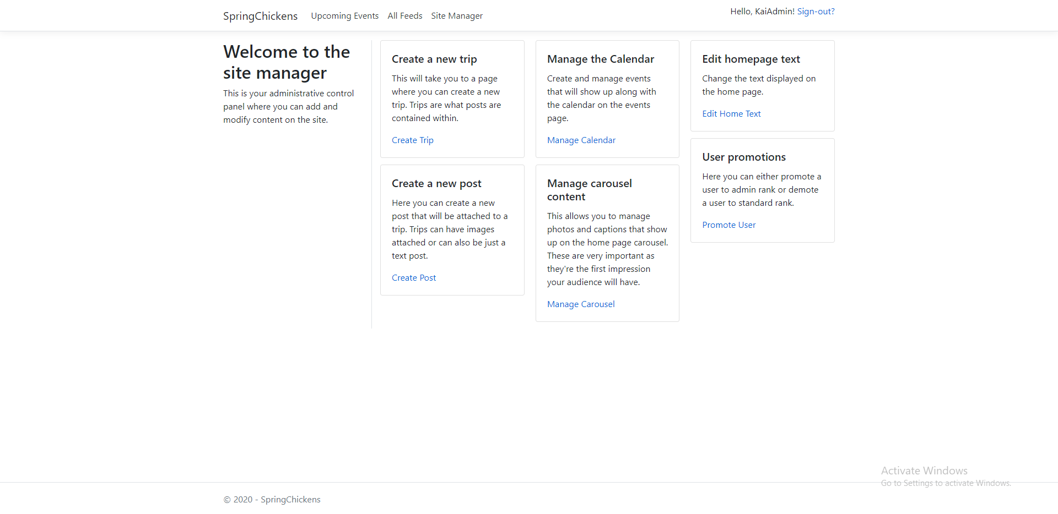

### Forgot password

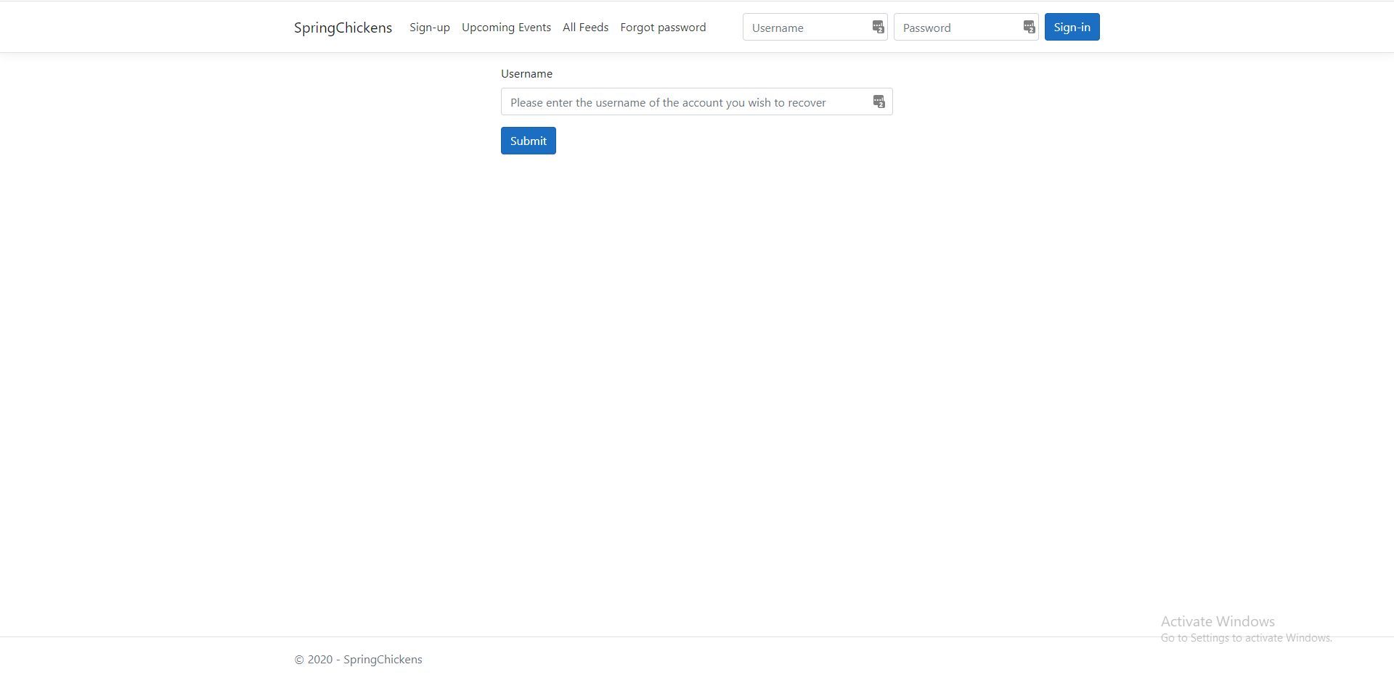

### New Trip

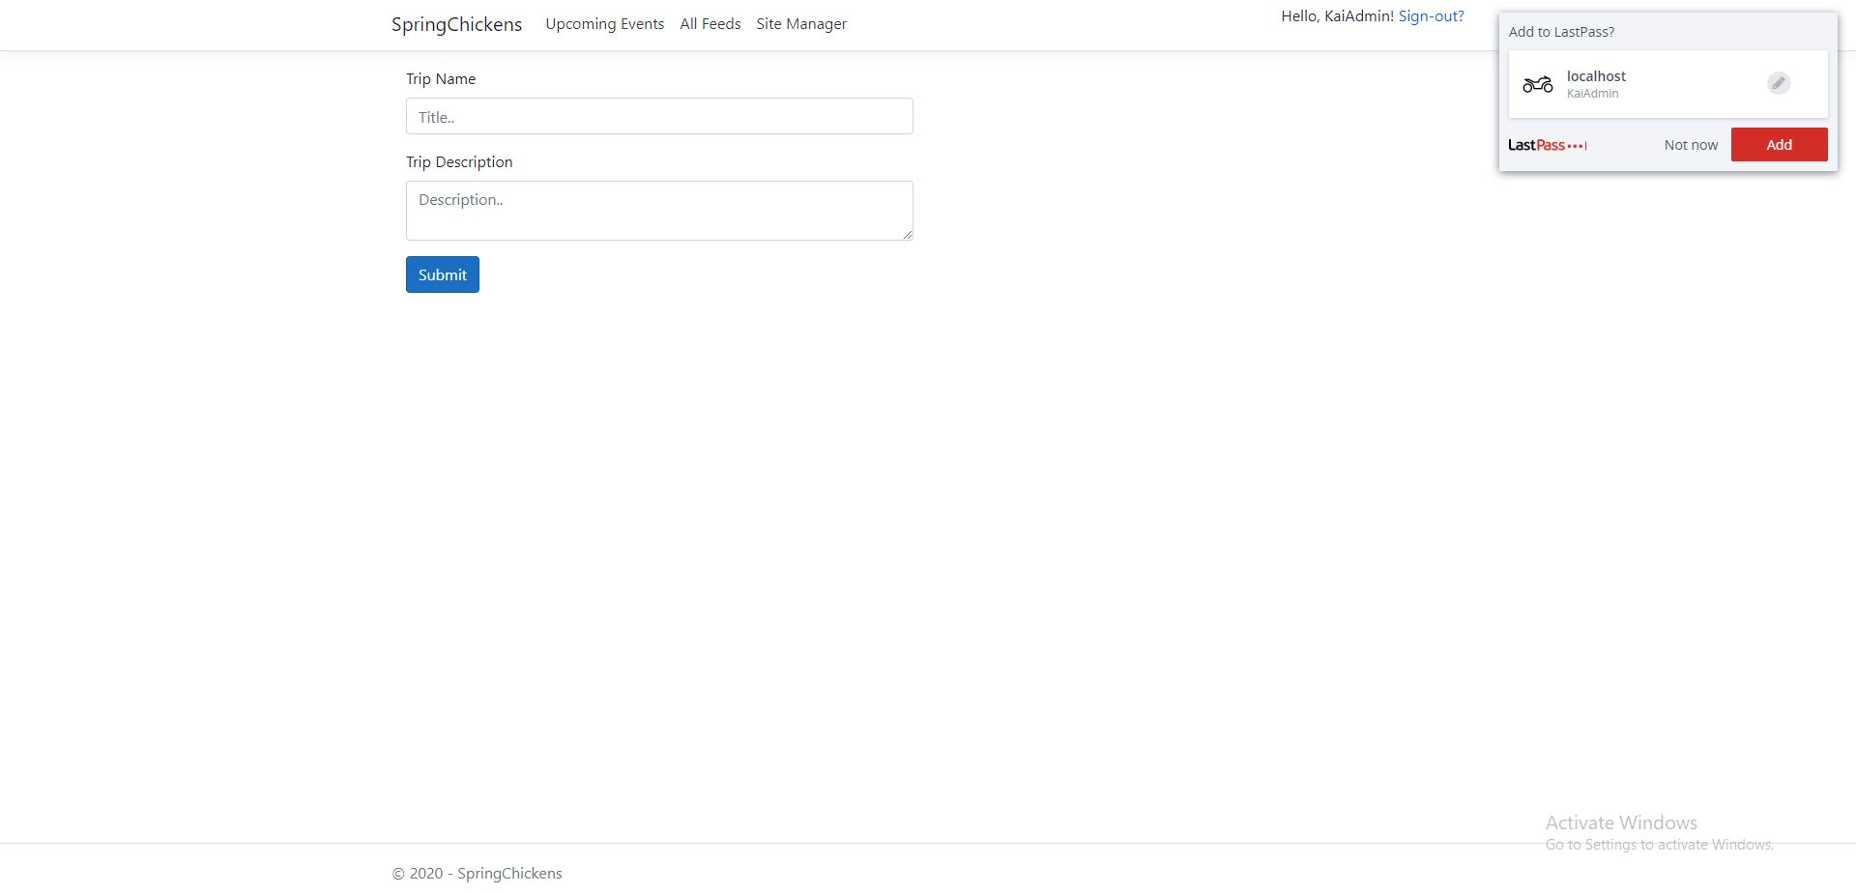

### New Post

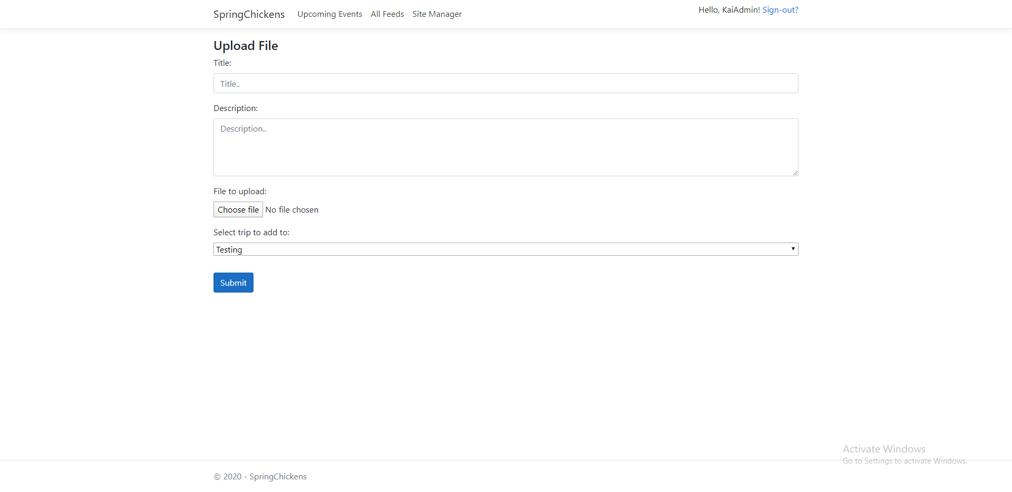

### Manage calendar

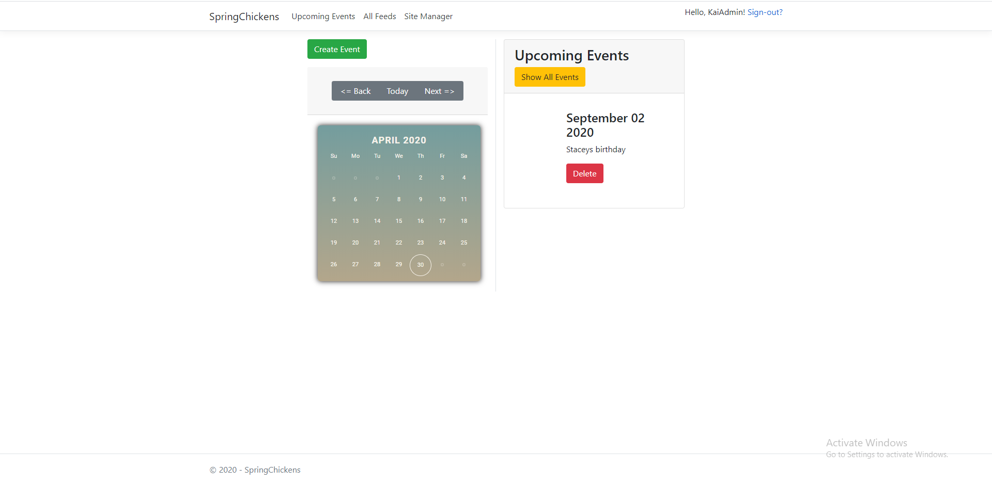

### Create event

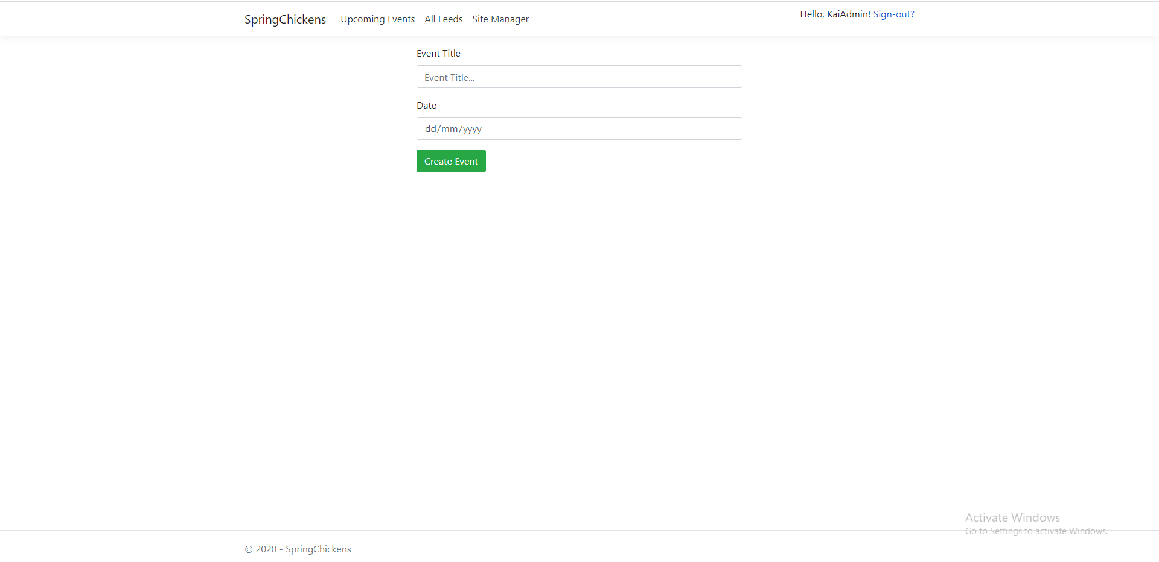

### Manage carousel

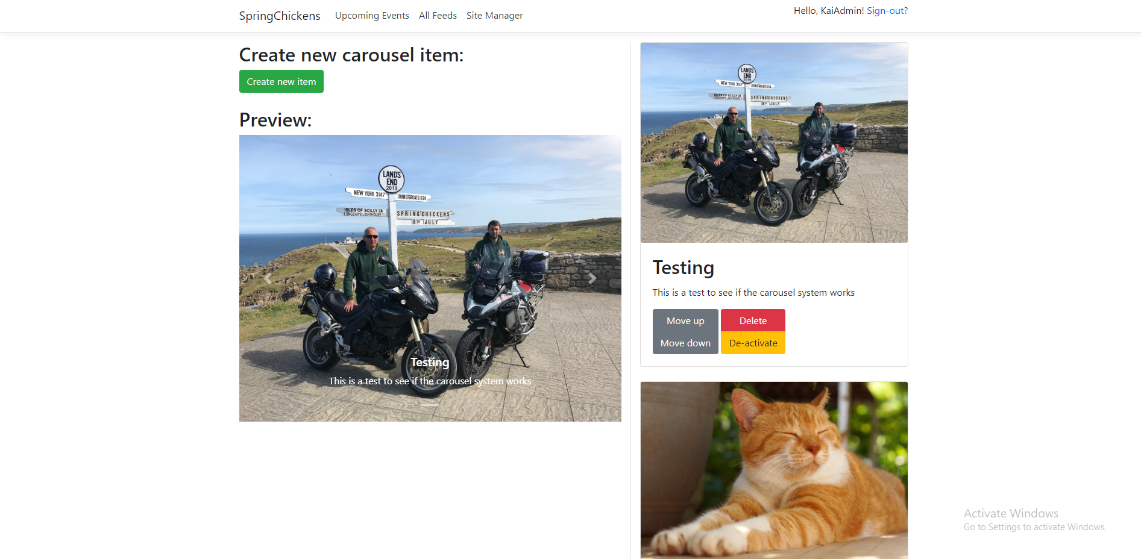

### New carousel Item

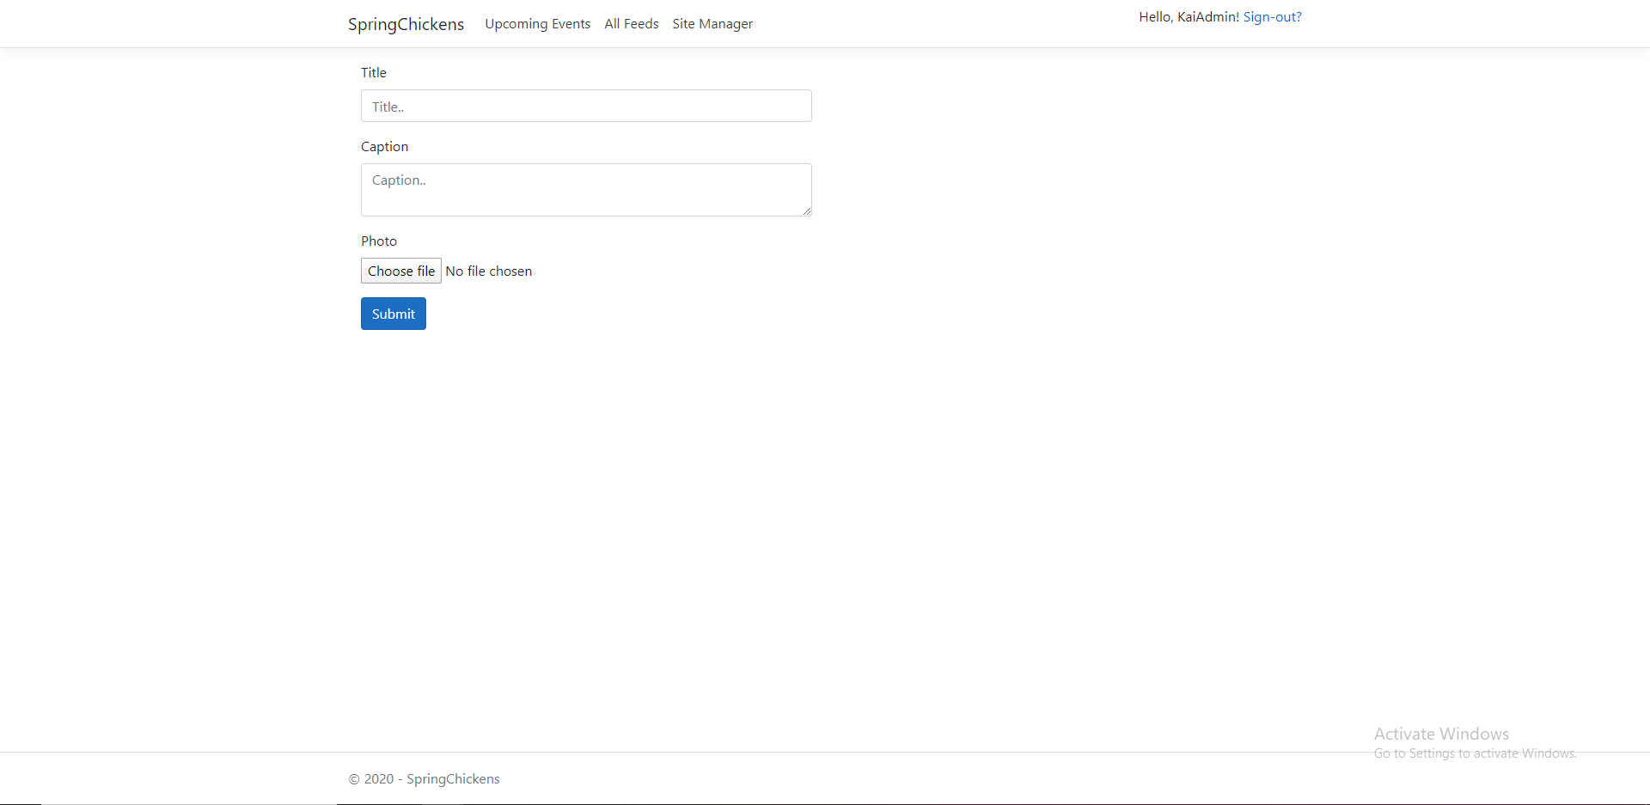

### Manage homepage text

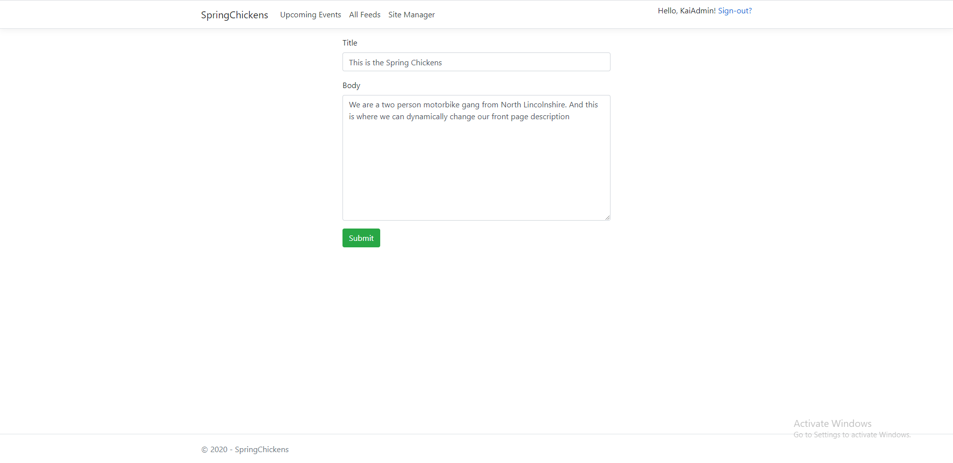

### User promotions

